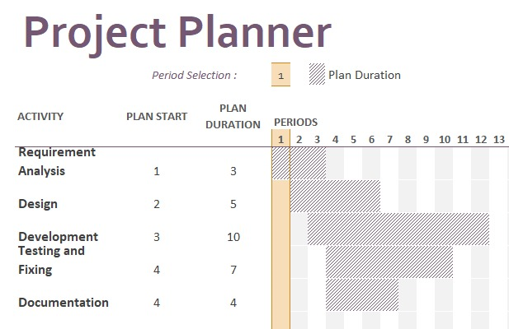

Project team: 3-member student team

Training and testing data: sample files such as documents, images, audio and video files (Examples: JPEG, PNG, PDF, DOCX, XLXS, MP3, WAV, etc).

Python libraries: The following Python libraries will be used in this project.

Flask – ideal for building web interface for users to interact with the system, as it is light-weight and easy to use. It has libraries that can handle file uploads and can validate and store uploaded files. (Aggarwal, 2019).

Werkzeug – useful for ensuring security in file handling and for handling communication between the server and the application, including tasks like template selection for requests and responses (Nokeri, 2022).

os – useful for various operating system-dependent functionalities such as managing file and directory operations

| Project team | 3-member student team |
| --- | --- |
| Training and testing data | Sample files such as documents, images, audio and video files (Examples: JPEG, PNG, PDF, DOCX, XLXS, MP3, WAV, etc). |
| Python libraries | The following Python libraries will be used in this project.   * Flask – ideal for building web interface for users to interact with the system, as it is light-weight and easy to use. It has libraries that can handle file uploads and can validate and store uploaded files. (Aggarwal, 2019). * Werkzeug – useful for ensuring security in file handling and for handling communication between the server and the application, including tasks like template selection for requests and responses (Nokeri, 2022). * os – useful for various operating system-dependent functionalities such as managing file and directory operations |

Aggarwal, S. (2019) Flask Framework Cookbook. 2nd ed.. Packt Publishing. Available from: https://www.perlego.com/book/1031659/flask-framework-cookbook-over-80-proven-recipes-and-techniques-for-python-web-development-with-flask-2nd-edition-pdf [Accessed 10 June 2023].

Casey, E. (2011) Digital Evidence and Computer Crime – Forensic Science, Computers and the Internet, 3rd ed. Academic Press.

Hoffman., C (2017) 50+ File Extensions that are potentially dangerous on Windows. Available from: <https://www.howtogeek.com/137270/50-file-extensions-that-are-potentially-dangerous-on-windows/> [Accessed 10 June 2023].

Nokeri, T.C. (2021) Web app development and real-time web analytics with Python: Develop and integrate machine... learning algorithms into web apps. S.l.: Apress.

Peng, S., Mukhopadhyay, S., Raje, R. & Palakal, M. (2001) A Comparison Between Single-agent and Multi-agent Classification of Documents. *Proceedings of the 10th Heterogeneous Computing Workshop* 2; 20090.2.

Russell, S., Norvig, P., Canny, J. & Malik, J. (2021) Artificial Intelligence: A Modern Approach 4th ed. Pearson.

Stuttard, D. & Pinto, M. (2011) The Web Application Hacker's Handbook: Finding and Exploiting Security Flaws. 2nd ed. Wiley Publishing.

Wooldridge, M.J. (2009) An Introduction to Multiagent Systems. Chichester: John Wiley & Sons.